**SPACES FOR CHANGE**

**&**

**THE SPECIAL CONTROL UNIT AGAINST MONEY LAUNDERING**





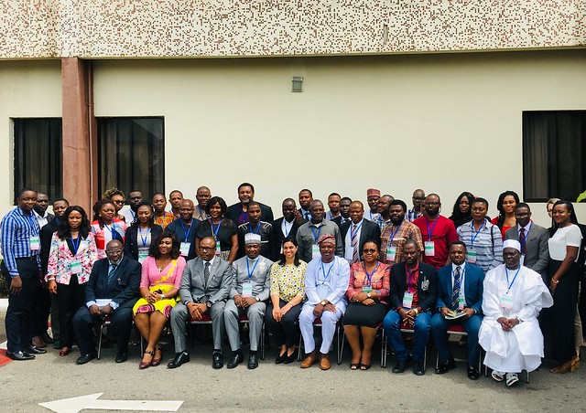

**Summary of Workshop Proceedings**

**Sensitization of NPOs on Money Laundering and Terrorism Financing Risks in the Non-Profit Sector in Nigeria**

SPACES FOR CHANGE | S4C and the Special Control Unit against Money Laundering (SCUML)

***with support from***

**Open Society Foundations and Fund for Global Human Rights**

# June 20, 2019

**I.** Introduction

In 2016, Nigeria published a [National Risk Assessment (NRA) on Terrorist Financing (TF) and Money Laundering (ML)](https://www.nfiu.gov.ng/images/Downloads/downloads/nrareport.pdf), which identified Designated Non-Financial Businesses and Institutions (DNFIs) as being amongst those sectors most vulnerable to money laundering (ML) and terrorist financing (TF). Nigeria classifies non-profit organizations (NPOs) as a subset of DFNIs. In a report released in March 2019,  [Unpacking the Official Construction of Risks and Vulnerabilities for the Third Sector in Nigeria](https://spacesforchange.org/wp-content/uploads/2019/03/FULL-REPORT.-UNPACKING-THE-OFFICIAL-CONSTRUCTION-OF-RISKS-AND-VULNERABILITIES-FOR-THE-THIRD-SECTOR-IN-NIGERIA_compressed.pdf) , S4C conducted an extensive analysis of the NRA and challenged the assessment of risks for the non-profit sector, disputing the official classification of NPOs as DNFIs and teased out the nuances between vulnerability and threat, among other issues.  It further assessed the adequacy of the legal framework for combating ML/TF risks in the non-profit sector.  The report aroused the interest of national AML/CFT regulators in Nigeria, generating intense debate, feedback and engagement between national security stakeholders and non-profit organizations (NPOs).

As a logical follow up towards consolidating the interest the report generated within the national security architecture in Nigeria, Spaces for Change and the Special Control Unit against Money Laundering co-hosted a workshop, Combating Money Laundering and Terrorism Financing Risks in Nigeria’s Nonprofit Sector on June 20, 2019.

Sixty-two participants attended the workshop in Abuja, Nigeria. The participants comprised a diverse mix of participants from civil society organizations from all six regions of Nigeria, religious and faith based organizations, officials of federal government ministries and agencies, intergovernmental bodies charged with the responsibility to regulate corporate oversight and combat economic and financial crimes such as the Corporate Affairs Commission (CAC), Federal Ministry of Justice, Economic and Financial Crimes Commission (EFCC), Nigeria Financial Reporting Council, Federal Ministry of Economic Planning and the Intergovernmental Group against Money Laundering in West Africa (GIABA).

The workshop aimed to deepen understanding of the risks of money laundering and terrorism financing in Nigeria’s non-profit sector and at the same time, enhance AML/CFT compliance culture within non-profit entities.

The workshop featured the following presentations and short interventions:

* Overview of the Relevant International Standards on AML/CFT as it Relates to NPO.
* Nigeria’s Anti Money Laundering/Countering Financing of Terrorism Regimes.
* Nigerian National (ML/TF) Risk Assessment Process, Findings and Action Plans.
* Risk Assessments of NPOs – Theory and Practice.
* How AML/CFT Regulations Engender Restrictions on the Civic Space and Recommendations for Improving Government -NPO Relations in Combating ML/TF.
* FATF/GIABA 2nd Round of Mutual Evaluation of Nigeria and the Role of the NPOs. The summary of these presentations are detailed below:

**I.** Overview of the Relevant International Standards on AML/CFT as it Relates to NPOs

In his opening remarks, Mr. Francis Usani, the director of the Special Control Unit against Money Laundering (SCUML), enlightened participants on the links between rising corruption levels in the country and terrorism financing, elucidating the role of the agency in combating such crimes. The chances of success for SCUML’s regulatory role are heightened by the cooperation and watchdog interventions of non-profit organizations; hence the need for collaboration and constant engagement.

The first presentation, *Overview of the Relevant International Standards on AML/CFT as it Relates to NPOs*, shed light on basic norms, international legal standards and the Financial Action Task Force (FATF) – an institution responsible for promoting effective implementation of the legal, regulatory and operational measures for combating ML and TF.

The FATF is an inter-governmental body established to coun­ter money laundering, financing of terrorism and other threats to the international financial system. It is both a policy making and enforcement body.

The FATF mandate was initially set out on and guided by 40 detailed Recommendations on ways to counter money laundering, but following the 9/11 terrorist attack on the United States of America, its mandate was expanded to also address terrorism financing and, 8 additional and Special Recommendations were added. In 2004, another Recommendation was added, bringing the total number of Recommendations to forty-nine.

The functions of the global body include:

* Conducting research on ways that criminals launder money and terrorist organizations raise and access funds.
* Setting global standards to promote the effective implementation of legal, regulatory and operational measures for combating ML and TF threats in both local and international financial system.
* Offering technical support to countries and mitigating risks and assessing how effective, various states’ implementation of AML/CFT mechanisms are working through rigorous peer evaluations.

Given the FATF’s significance and influence on the international financial system, non-compliance to its recommendations can attract interna­tional political pressure, negative country risk ratings which ultimately results in restrictions from the international financial community hence, states continuously work to mitigate perceived financial and terrorism threats and risks in their economic systems.

**Key points raised during this session**

1. With the increase of various forms and crimes of ML and TF, countries across the world are increasingly required to implement regulatory systems that enhance government’s oversight of financial systems over various sectors of an economy which includes the nonprofit sector.
2. According to the FATF, a nonprofit organization refers to a ‘***a legal person or arrangement or organization that primarily engages in raising or disbursing funds for purposes such as charitable, religious, cultural, educational, social or fraternal purposes, or for the carrying out of other types of good works***.
3. The FATF’s Recommendation 8 sets out best practice for the assessment of a country’s NPO sector. Accordingly, AML/CFT authorities are required to undertake a risk assessment of the non-profit sector to identify vulnerabilities and threats and subsequently evaluate and strengthen the sufficiency of the country’s available legislation for counteracting money laundering and terrorism financing risks identified in the sector.
4. Both international and local regulations require that NPOs conduct due diligence to protect themselves from abuse by keeping records of transactions, establishing internal controls across board in the organization, checking the identities, sources of fund and wealth in some cases of individuals, partners, donors.
5. To combat the financing of terrorism and prevent the proliferation of nuclear, chemical and biological weapons, the United Nations Resolution 1540 and 2396, requires countries to develop and establish domestic control measures to control terrorism financing and also prevent the spread of weapons of mass destruction. Accordingly, Nigeria’s Nuclear Regulation Agency is charged with the responsibility of addressing issues related to such materials.
6. NPOs can also conduct due diligence of partners and donors by searching on the United Nations

Terrorist Watch List for confirmations and verifications of the identity and status of associates.

**II.** Nigeria’s Anti Money Laundering and Counter Financing of Terrorism Regimes

The primary legislations governing money laundering in Nigeria are the Money Laundering (Prohibition) Act, 2011(as amended), the Economic and Financial Crimes Commission and the Central Bank of Nigeria Act (Anti-Money Laundering and Combating the Financing of Terrorism in Banks and Other Financial Institutions in Nigeria).

**Key points raised during this session**

1. These laws prohibit making or accepting cash payments of sums exceeding statutory provisions; for

instance, it is illegal for any individual to accept or make any cash payment that exceeds five million

naira. The law demands financial institutions and designated non- financial institutions to report to

the EFCC any lodgment or transfer of funds in excess of five million naira within seven days.

1. In accordance to Nigeria’s AML/CFT regulations, institutions must always preserve records, report

suspicious transactions, and conduct due diligence on customers and associates.

1. In Nigeria, NPOs are classified as Designated Non-Financial Institutions| DNFIs. DFNIs are required to

register with the Special Control Unit against Money Laundering.

1. SCUML is the major regulatory body for non-financial institutions in Nigeria. The agency was established

in 2005 to monitor, supervise and regulate the activities of DNFIs across the country.

1. Other legislations binding corporate bodies in Nigeria, including NPOS are the Companies and Allied Matters

Act (CAMA) & Company Regulation 2013, Financial Reporting Council Act, 2011 and Not-For-Profit Organization Governance Code 2016, Prevention of Terrorism Act, 2011, Federal Inland Revenue (Establishment) Act, Ministry of Budget and National Planning Act 1993 etc. All these laws lay down provisions that guide the internal and external functioning of profit and non-profit organizations, counter the financing of terrorism and prevent money laundering.

1. For instance, under the Companies and Allied Matters Act, NPOs are prohibited from making gifts or donations to political parties for any purpose and are also required to submit periodic annual and financial reports to the Corporate Affairs Commission (CAC). The CAC is one of the primary regulators of nonprofit organizations in Nigeria. It exercises oversight over the operational management of registered NGOs.

**III.** Nigeria National (ML/TF) Risk Assessment Processes, Findings and Action Plans

A National Risk Assessment is the assessment of ML/TF risks elements existing within a system (financial and

non-financial). This assessment determines the sectors of an economy vulnerable to threats and risks of

money laundering and financing of terrorism. It uses a risk-based approach to deploy efficient allocation of resources to mitigate identified risks.

An NRA aims to evaluate a country’s existing ML and TF regime to determine if they are sufficient enough to tackle financial crimes and terrorism risks. NRAs are elaborate exercises involving many different stakeholders and conducted over a period of months.

**Vulnerabilities**

Vulnerabilities are exploitable weaknesses in both internal and external systems and procedures.

**Vulnerabilities**

Threats

Threats refer to any person, group, object or activity with the potential to cause harm to the state, society or its economy.

**Threats**

**Vulnerability**

**Survey**

**Risk Mitigation**

**Measures**

**Risk Mitigation Measures**

Shore up weaknesses by reviewing adequacy of existing measures and strengthening security structures to effectively combat dangers.

**Risk**

**Assessment Processes**

1. The Nigerian NRA was conducted in 2016 in three phases - Phase 1: Inauguration, Preparation, Identification and Initial Assessment; Phase 2: Data Collection, Analysis and Production; Phase 3: Finalize Report, Disseminate & Implement.
2. The World Bank tool was utilized for Nigeria’s assessment due to the nature, size and complexities of the country’s political structure, financial sector and economy and the tool’s excel-based model which is useful for identifying drivers of ML/TF. The tool also comprises interrelated modules built on input variables that represent factors related to money laundering threats and vulnerabilities.
3. The Nigeria NRA team consisted of nine multidisciplinary working groups with experienced professionals drawn from various ministries, departments, and agencies, including the private sector.
4. Part of the assessment involved collecting quantitative data from regulatory bodies and private entities, field survey executed through the use of questionnaires and focus group discussions that interviewed participants across the six geopolitical zones of the country. Additional information was also gotten from secondary sources like annual reports and other sundry publications.

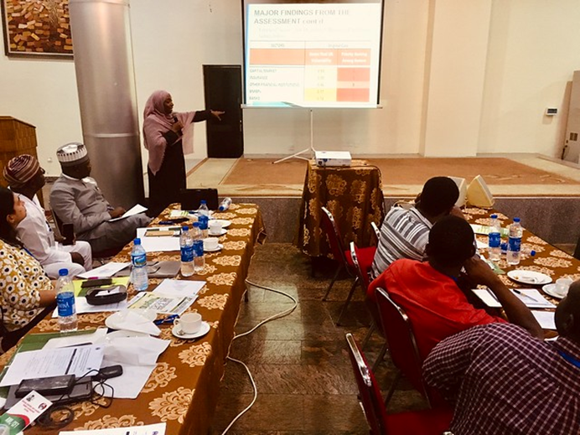**Findings**

* The Money Laundering risk level in the country was rated **MEDIUM HIGH**. This was arrived from a ***Medium High*** ML threat as well as a ***Medium High*** ML vulnerability.
* Overall Terrorism/Terrorist Financing Risk was rated **MEDIUM**. This was derived from an overall Terrorism/Terrorist Financing Threat of ***Medium*** and an overall Terrorism/TF Vulnerability- ***Medium***.
* **The Nigeria NRA reflects that although the abuse of NPOs for ML seem potentially low, NPOs however pose a significant threat due to the fact the Designated Non-Financial Businesses and Professions (DNFBP) sector is poorly regulated.**
* The major **Money Laundering threats** that influenced the Nigerian NRA ratings include but not limited to the following: bribery and corruption, pipeline vandalism and illegal bunkering, drugs trafficking, kidnapping for ransom, cash smuggling, arms trafficking.
* Similarly, the most significant **Money Laundering vulnerabilities** include the following: Non comprehensiveness of asset forfeiture laws, unavailability of reliable identification infrastructure, lack of access to beneficial ownership information, limited capacity and resource for financial crime investigators, prosecutors and judicial processes, low quality of border controls, inadequate controls of cash and similar transaction instruments, high level of the informal economy.
* The following were the identified **Terrorism/Terrorist Financing threats** to the country: The pattern of domestic financing of terrorist groups like Boko Haram and the fact that the country has not recorded any success in prosecuting or convicting anybody of financing terrorism in Nigeria. This is because funds used to finance terrorism are not channelled through formal financial institutions.
* The result of the country’s assessment on its **vulnerability to Terrorism/Terrorist Financing** revealed that: The DNFBP sector has minimal regulation – like the inefficient reporting of suspicious transactions from the sector, the non-functional state of the Nigerian sanctions committee that is supposed to drive the implementation of the United Nations Security Council Resolutions on terrorism financing and weapons of mass destruction, a lack of centralized database for national agencies to share intelligence on terrorism/terrorist financing and limited domestic cooperation among relevant stakeholders.

**Action Plans**

The following but not limited to, were major action plans birthed from the findings of the national risk assessment:

* The consolidation of all disparate databases of convicted persons within and outside the country.
* Strategies to develop a tighter border control.
* The deployment of more funds to boost the efficiency of the National Identity Management Control. This is important to aid the institution capture and maintain a robust database of the growing population size of the country.
* Review the proposed amendment of the Companies and Allies Matters Act (CAMA) to ensure the requirement for comprehensive details on beneficial ownership information of registered entities is mandatorily and fully provided by both private and public quoted companies.
* Provide specialized trainings for local AML/CFT regulators to expose them to international best practices of conducting and following up on a national risk assessment.
* Organize and conduct outreaches and training sessions for DNFIs/DNFBIs and financial institutions on AML/CFT obligations.

The FATF requires countries to undertake a terrorism financing risk assessment of the NPO sector in order to identify threats and vulnerabilities. Country authorities are however informed to perform the assessment using a risk-based approach that identifies the vulnerabilities of NPOs, the vulnerable NPOs and evaluate the sufficiency of available legislation for counteracting the risks. This is in order to avoid a blanket classification of all NPOs as vulnerable and, deploy effective mitigating measures to the clearly-identified risk areas.

**IV.** Nigeria Risk Assessment of NPOs – Theory and Practice; The Need for a Risk Based Approach.

Despite the FATF’s recommendation, some countries have continued to directly or indirectly justify the passage of restrictive laws in the name of countering terrorism. These over regulations have been characterized by burdensome reporting requirements for NPOs which are disproportionate to TF/ML risks, clampdown on legitimate NPO activities and freedoms, imposition of draconian legislations that demand complex registration requirements of NPOs and high penalties for non-compliance which do not commensurate with risks identified.

**Key points raised during this session**

1. A risk-based approach would require country AML/CFT authorities to identify, assess and understand the ML/TF risks to which they are exposed to and deploy measures commensurate to those risks in order to mitigate them effectively.
2. Although the FATF does not classify NPOs as Designated Non-Financial Businesses and Professions (DNFBP) the Nigerian regulation however classifies NPOs as DNFBPs.
3. This classification of NPOs as DNFBPs influenced the assessment outcomes of the sector in the 2016 NRA conducted by the Nigerian government as the NPO sector was not assessed as an independent sector of the economy; the sector was assessed as together with other businesses and professions that operate differently.
4. A risk-based approach assessment of the NPO sector will specifically seek to understand the vulnerabilities of NPOs in Nigeria to financing of terrorism by identifying the subset of NPOs most at risk of being abused for TF.
5. In applying countermeasures to respond and deal with identified threats and risks in the NPO sector in Nigeria, a cautious approach must be taken to avoid the unintended consequence of restricting the freedoms, operational space and capacity of genuine organizations.
6. Beyond the assessment of the sector, government must conduct and sustain periodic outreaches with NPOs to update organizations on AML/CFT practices and also strengthen Government -NPO relations.
7. NPOs can also mitigate the risk of abuse by adopting self-regulatory measures, becoming responsible partners and ensuring compliance to AML/CFT practices and policies.

A lot of opportunities exist for collaboration and improved partnership between government and the non-profit sector in the fight against ML/TF. These opportunities have however not been adequately explored because often times both parties view the motives of each other with distrust. These suspicions are fueled by unfounded stereotypes that present a negative perception of the structure and workings of both groups in the eyes of each other.

**V.** Improving Government – NPO Relations in Combating ML/TF Through Enhanced Communication and Fit for Purpose Regulations.

For instance, AML/CFT regulators are unaware of existing reporting practices and obligations to donor bodies in the sector, and therefore tend to introduce legislative measures that reinvent the wheel, instead of leveraging industry best practices to heighten transparency and accountability in the sector. On the other hand, NPOs are sometimes unaware of the drivers behind AML/CFT regulations, hence view certain compliance requirements by government authorities as attempts to restrict their space.

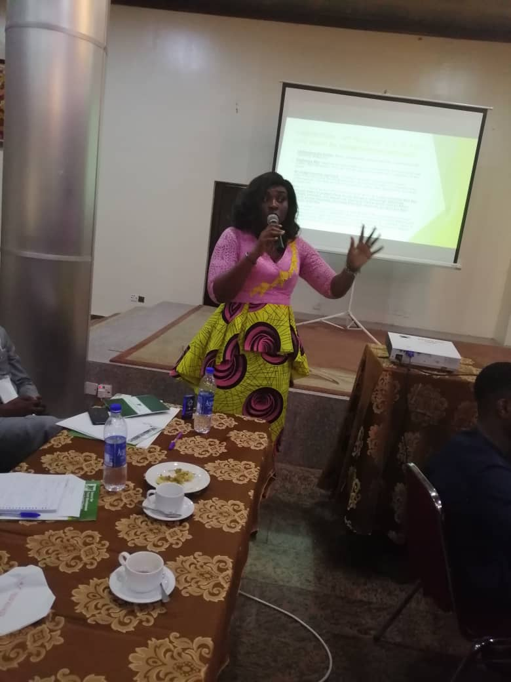

**‘Communication gap is one the biggest obstacles impeding government -NPO relationships…’’**

**Victoria Ibezim – Ohaeri – Spaces for Change.**

**To enhance compliance of non-profit organizations to AML/CFT measures…**

* AML/CFT regulators need to understand the disparate organizational characteristics of NPOs operating in Nigeria.
* This understanding will help them avoid the one-size-fits-all and sledge-hammer approach in the execution of AML/CFT measures.
* Blanket restrictions across the entire sector without regard for the distinct NPO characteristics and varying TF risk exposure levels not only endangers the legitimate operations of organizations but also widens the disconnect between government and civil society.
* NPOs must strive to understand the risks of ML ad TF, seek collaborations with government to find solutions to terrorism, money laundering and financing of terrorism.

# Communication, Coordination, Cooperation is the key!

**VI.** FATF/GIABA 2nd Round of Mutual Evaluation of Nigeria and the Role of NPOs

The workshop wrapped up with a presentation on Nigeria’s forthcoming FATF Mutual Evaluation scheduled to hold in September 2019 and what is expected from NPOs in Nigeria.

**What is a Mutual Evaluation Exercise?**

The FATF regularly monitors the progress of members in implementing its Recommendations through a Mutual Evaluation process. This process consists of a peer review where members from different countries assess another country. The assessment constitutes of an analysis of a country’s anti-money laundering and countering financing of terrorism mechanisms. It reviews the effectiveness of the country’s AML/CFT legislative, regulatory and supervisory architecture. Whereupon, the findings from the exercise are discussed at the FATF’s next plenary session and adopted in a Mutual Evaluation report (MER).

A typical cycle of the FATF evaluation process takes 7 - 8 years to complete with a preparation stage that entails the formulation of an evaluation team and a desktop review of a country’s laws and regulations. During Evaluation/Onsite visits, evaluators meet with government officials, institutions and representatives from different sectors to discuss the effectiveness of a country’s AML/CFT system. Afterwards, a MER is prepared during the Post-Evaluation stage where evaluators discuss the findings with both country and FATF officials.

The MER is then adopted by the FATF plenary and published. From then on, FATF-styled regional bodies, in this context the Inter-Governmental Action Group against Money Laundering in West Africa (GIABA) which is a specialized institution of the Economic Community of West African States responsible for facilitating the adoption and implementation of Anti-Money Laundering and Counter-Financing of Terrorism in West Africa, conducts periodic follow ups.

The MER documents findings border on the technical compliance (if the laws regulating ML/TF are existent in the country) and the effectiveness of implementation also known as Immediate Outcomes (to what extent a country’s AML/CFT measures have been able to control related abuses). Ratings on technical compliance vary from Non-Compliant, Partially Complaint, Largely Compliant and Fully Complaint. Ratings on the effectiveness of implementation are classified as High, Medium High, Medium Low and Low.

Nigeria is currently preparing for a Mutual Evaluation Review (MER) which will be conducted by GIABA and FATF. The country was supposed to undergo this round of evaluation two years ago but was unable to scale through due to some technical details. This time around, the national risk assessment has been conducted and AML/CFT regulations enhanced for better efficiency. The country hopes that its latest efforts in implementing global AML/CFT standards will yield a favorable rating from evaluators.

Were NPOs involved in the NRA? NPOs were not drawn into the assessments due to the non-profit’s low knowledge and compliance with AML/CFT obligations, which can attract a low rating during a mutual evaluation exercise. Hence, it is imperative for organizations to key into the process, understand their obligations, adopt a robust internal AML/CFT compliance culture and submit themselves to supervisory measures as required by law.

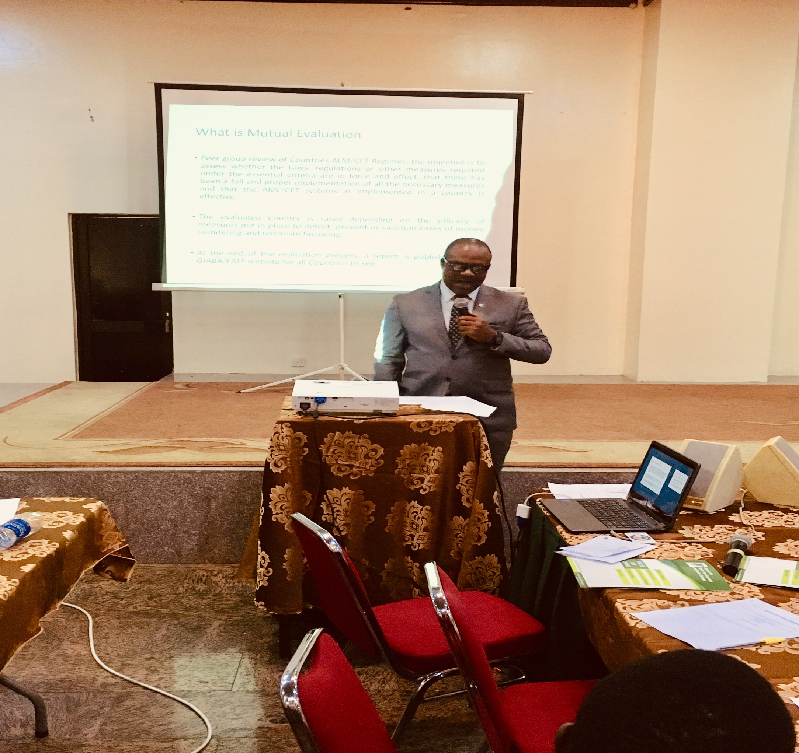NPOs were further advised to always submit to the supervisory activities of SCUML. The cooperation of NPOs would greatly help to secure the sector against threats of money laundering and terrorism financing.

This presentation sparked a frank conversation about AML/CFT regimes applicable to the NPO sector in Nigeria. The majority of participants acknowledged they were learning about the NRA for the first time, and appreciated the wealth of new information shared at the workshop which enlightened them about their AML/CFT reporting obligations under extant laws for the first time.

One major highlight of the workshop was the amnesty granted to non-profit organizations who were yet to comply with SCUML regulations, specifically the submission of cash transaction reports. The amnesty was granted because a lot of participants acknowledged being unaware of their reporting obligations to SCUML, but for the workshop.

**VII.** Recommendations and Takeaways

* The civil society is an ally of the government and is fully committed towards participating and engaging meaningfully in the country’s forthcoming mutual evaluation exercise. Nigerian AML/CFT authorities must see therefore NPOs as partners in the fight against ML/TF.
* Collaboration between regulators and the non-profit stakeholders is key in the fight to combat money laundering and terrorism financing in the NPO sector. Constructive engagement between AML/CFT regulators and NPOs is needed to deepen trust and boost the overall effectiveness of AML/CFT regimes.
* Adopting a risk-based approach in AML/CFT regulation is critical. This can help regulators obviate the resort to blanket classifications that restrict the civic freedoms and operational space for nonprofit organizations.
* Periodic outreaches must be conducted in order to sustain the conversation, bridge the knowledge gap and keep organizations abreast of current AML/CFT issues.
* NPOs on the other hand need to heighten due diligence in their financial operations, including aligning their charitable, humanitarian and other good works with AML/CFT guidelines.
* Communication is important – AML/CFT authorities must also consider developing regional and national strategies for disseminating AML/CFT information so as to enhance compliance across the board.

***The End***

Special thanks to our Donors and Partners for their kind support in making this workshop a success.





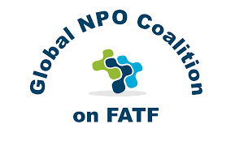

**Address: Telephone: Website & Media Handles:**

**7, Independence Street, Anifowoshe, Ikeja, Lagos, Nigeria. 070362020174, 09094539638** [**www.spacesforchange.org**](http://www.spacesforchange.org)

**49, MCC/Uratta Road, Ikenegbu, Owerri, Imo State, Nigeria. 09060643893 Twitter: @spacesforchange**

**Email:** [**spacesforchange.s4c@gmail.com**](mailto:spacesforchange.s4c@gmail.com) **Facebook: Spaces for Change.S4C**

[**info@spacesforchange.org**](mailto:info@spacesforchange.org)

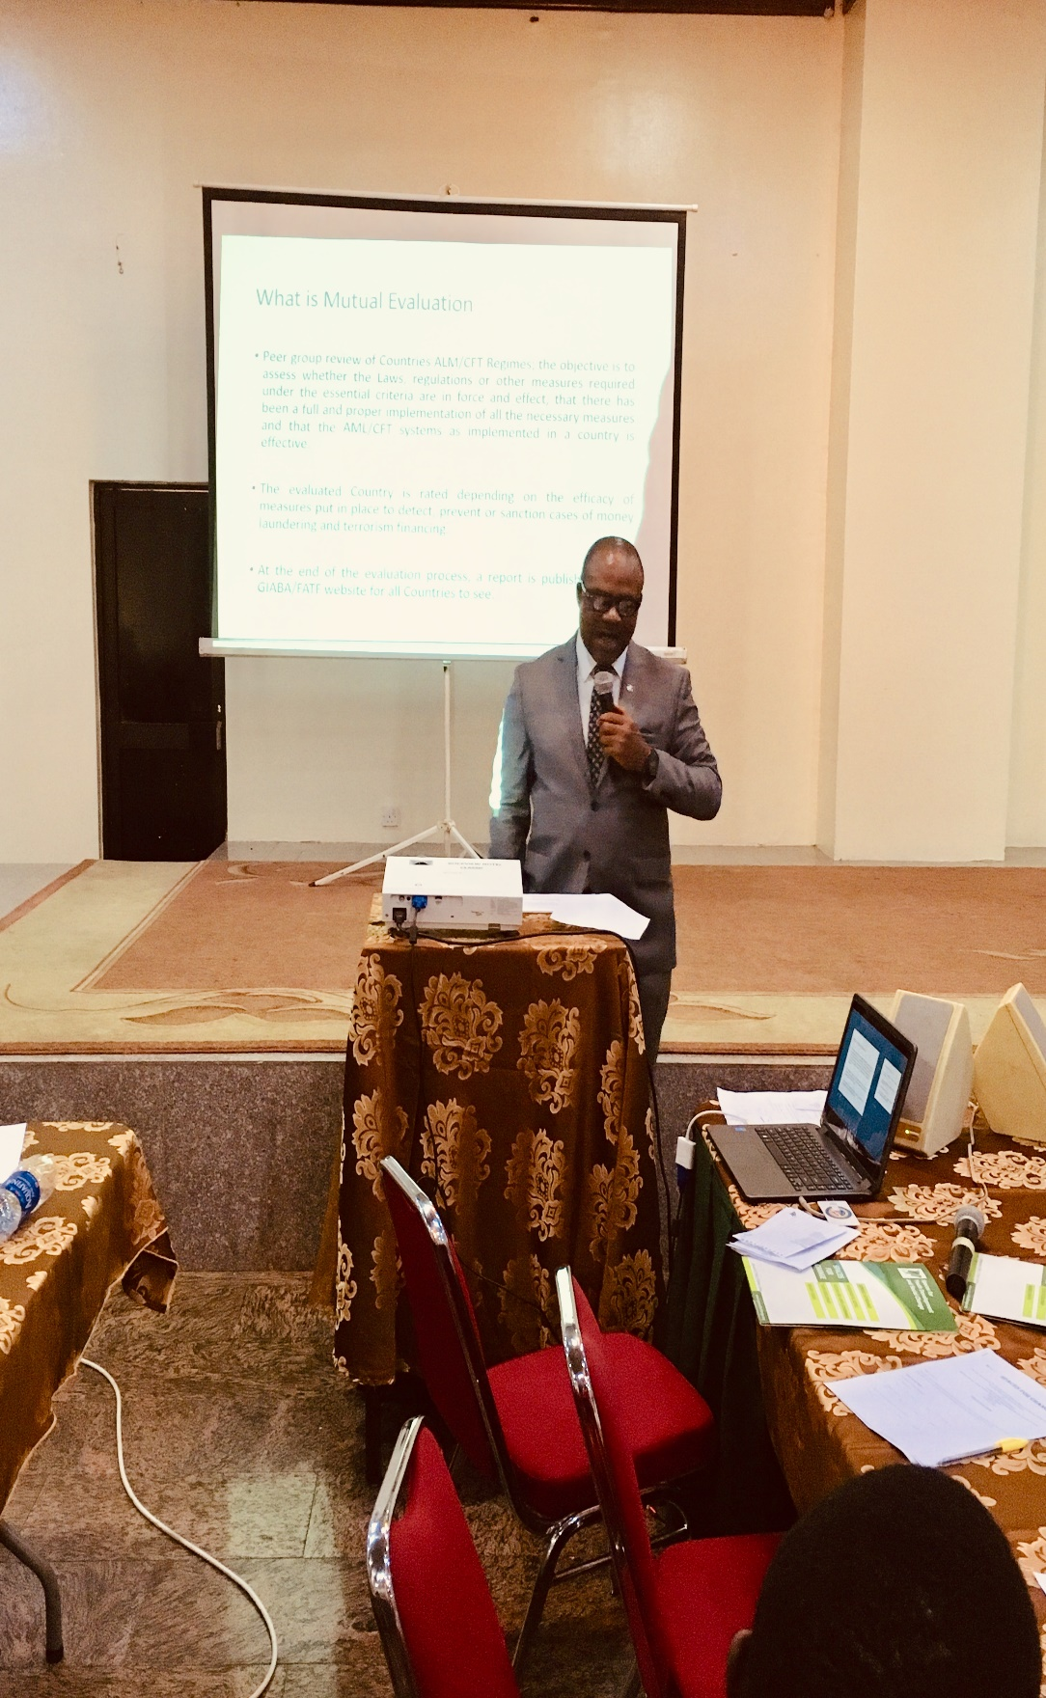

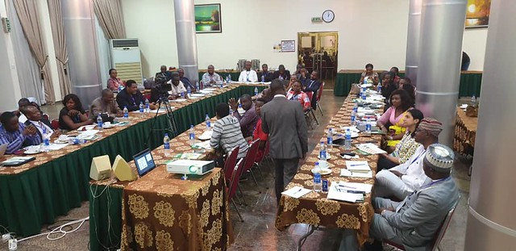

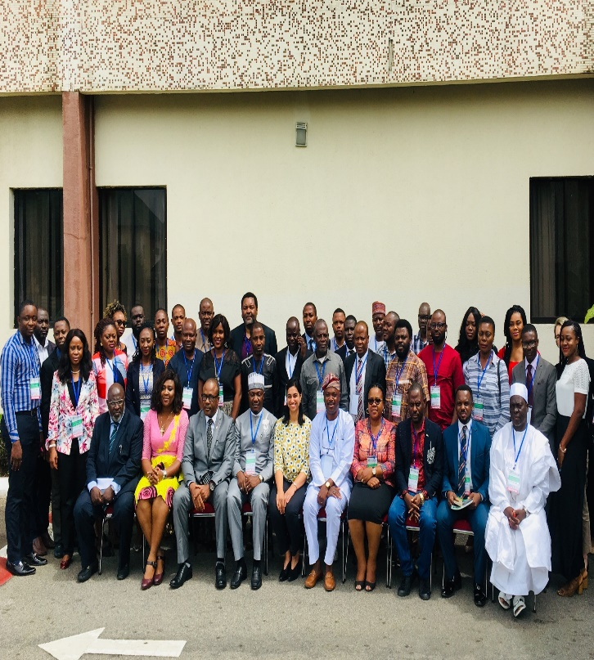

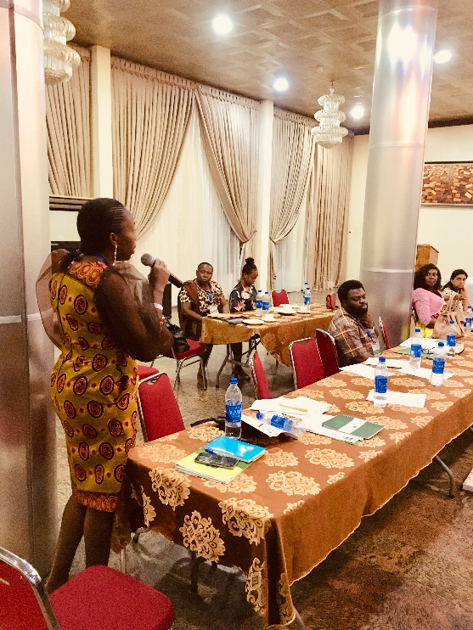

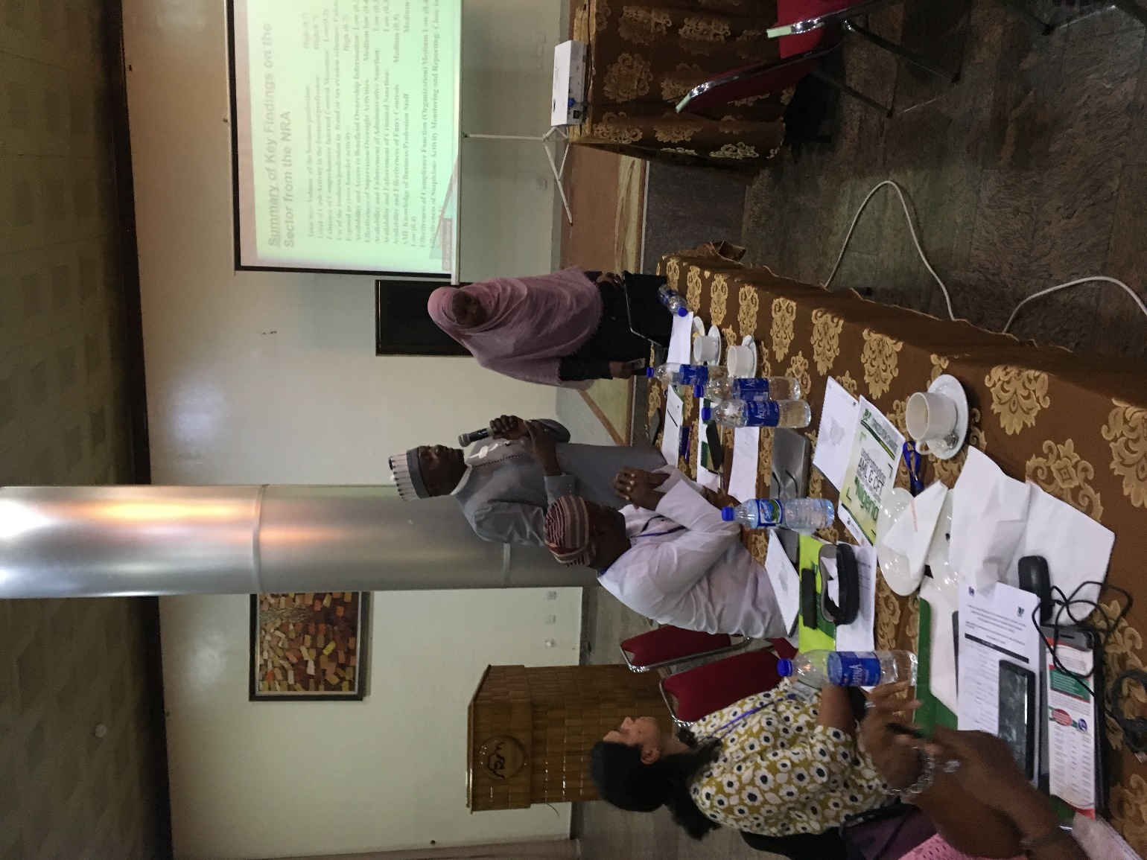



**Thank you!**